**Project Design Phase-II**

**Technology Stack (Architecture & Stack)**

|  |  |
| --- | --- |
| Date | 03 November 2022 |
| Team ID | PNT2022TMID43211 |
| Project Name | Nutrition Assistant Application |
| Maximum Marks | 4 Marks |

**Technical Architecture:**

The Deliverable shall include the architectural diagram as below and the information as per the table.

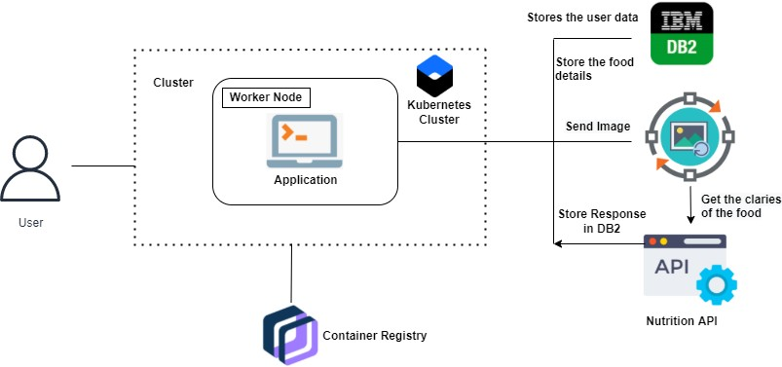

**Table-1 : Components & Technologies:**

|  |  |  |  |
| --- | --- | --- | --- |
| **S.No** | **Component** | **Description** | **Technology** |
|  | User Interface | Simple and interactive user interface for web application | HTML, CSS, JavaScript |
|  | Application Logic-1 | Logic for a process in the application | Python, flask |
|  | Application Logic-2 | Logic for a process in the application | IBM Watson STT service |
|  | Database | Data Type, Patient data ,Health report, Diet plan Configurations etc. | MySQL |
|  | Cloud Database | Database Service on Cloud | IBM DB2 |
|  | File Storage | File storage requirements | IBM Block Storage or Other Storage Service or Local File system |
|  | Infrastructure (Server / Cloud) | Application Deployment on Local System / Cloud  Local Server Configuration:  Cloud Server Configuration : | Local, Cloud Foundry, Kubernetes |